Insight 1 — Low Conversion Rate (22.46%)
- Only a small percentage of visitors complete purchases.
- Most traffic is leaving without converting.
- Current funnel is inefficient for revenue generation.
- AI-based personalization can improve conversion rates.

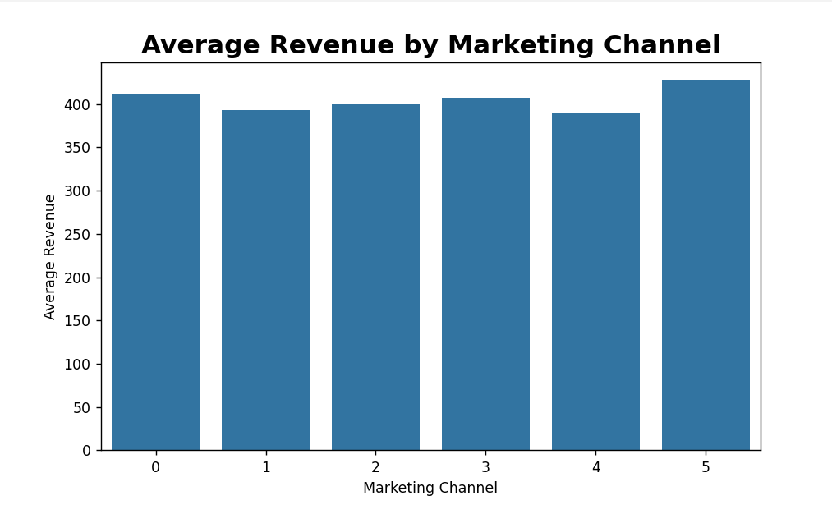

Insight 2 — High Cart Abandonment (42%)
- Many users add products but do not complete checkout.
- Checkout or payment friction likely exists.
- Mobile UX or trust issues may affect customers.
- Retargeting campaigns can recover lost revenue.

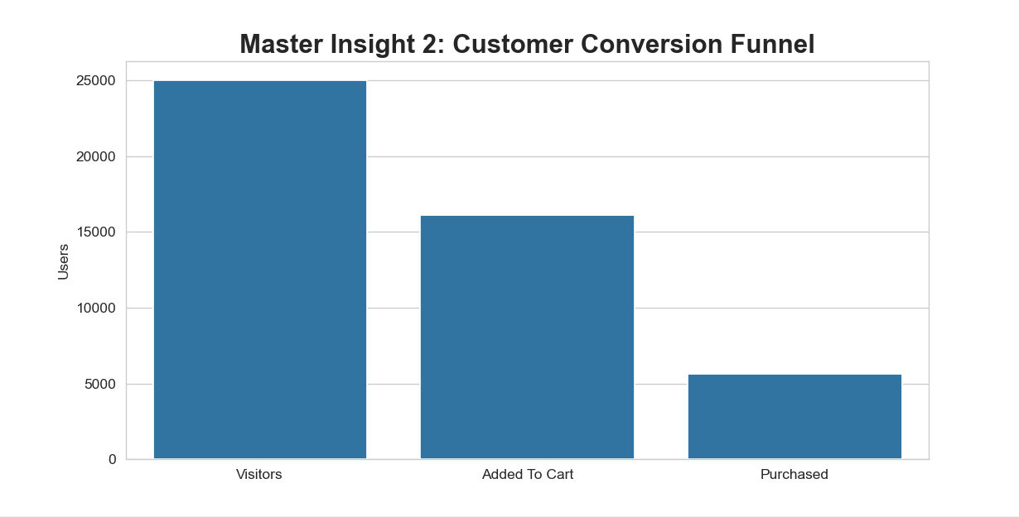

Insight 3 — Best Marketing Channel Performance
- Marketing Channel 5 generates the highest revenue.
- This channel attracts high-intent customers.
- Ad budget should be increased for this channel.
- Underperforming channels need optimization.

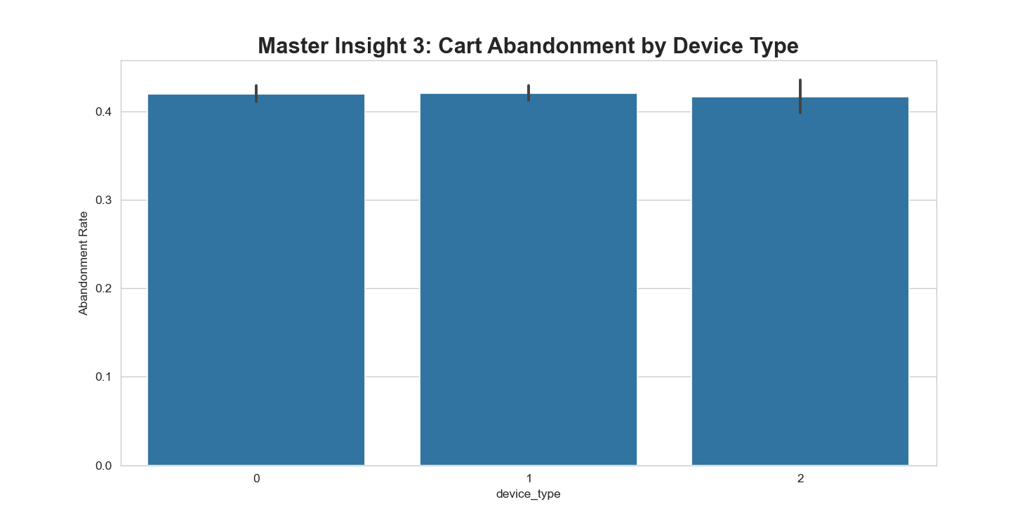

Insight 4 — Revenue Predicts Purchase
- High-revenue sessions strongly correlate with purchases.
- Premium customers show stronger buying intent.
- AI models can identify valuable customers early.
- Smart targeting can improve ROI significantly.
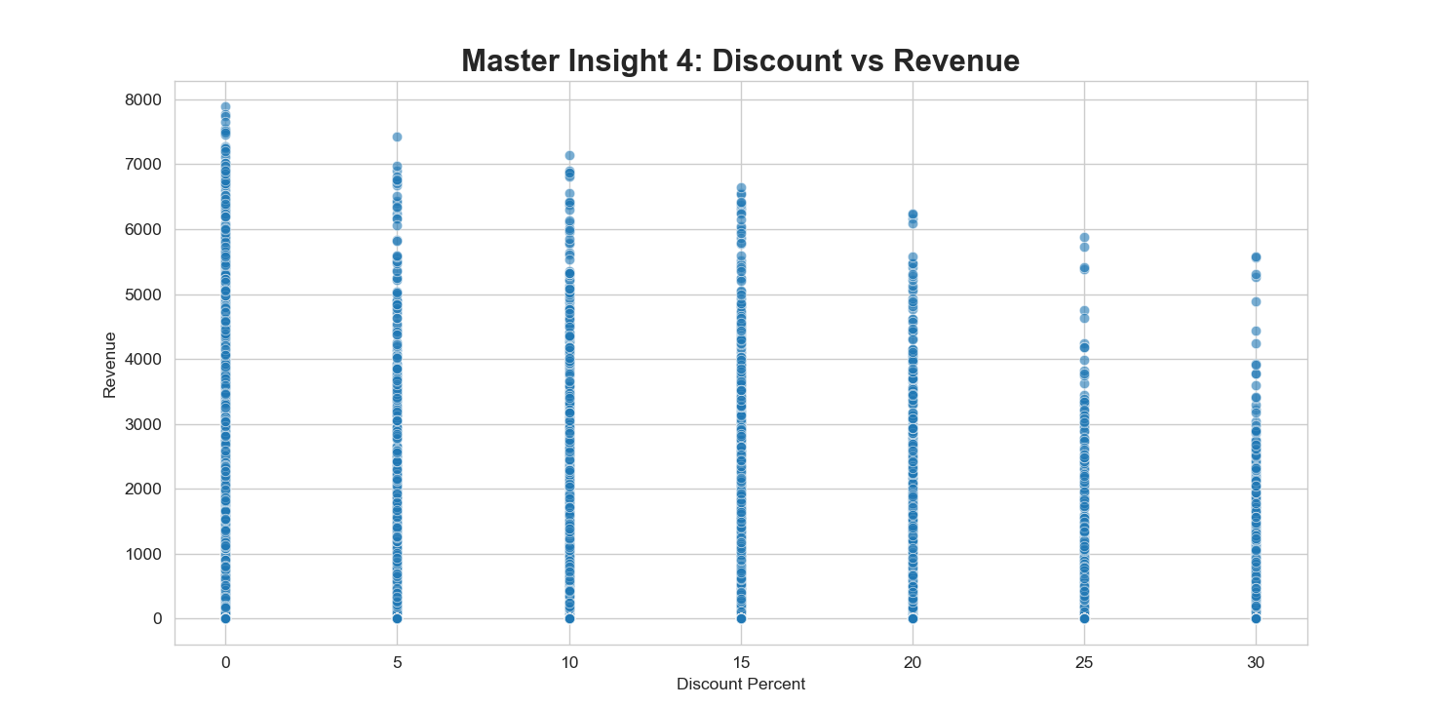

Insight 5 — Device Type 2 Converts Best
- Device Type 2 users purchase more frequently.
- User experience is likely smoother on this device.
- Device-specific optimization can boost sales.
- Marketing campaigns should focus on this segment.

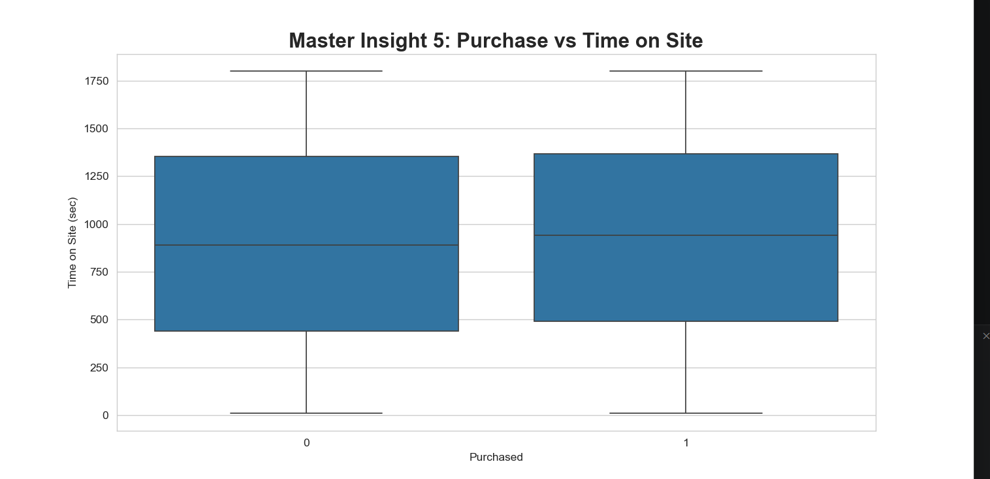

Insight 6 — August is Peak Revenue Month
- Revenue reaches maximum during August.
- Seasonal demand is clearly visible.
- Inventory and marketing should increase before August.
- Festival-based campaigns can maximize profits.

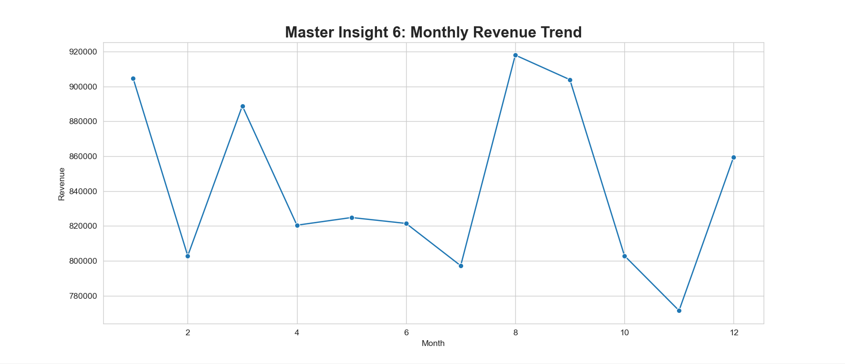

Insight 7 — Product Category 2 Leads Revenue
- Category 2 contributes the highest sales.
- Customer demand is strongest in this category.
- More promotions and bundles should be introduced.
- Premium product expansion can increase profits.

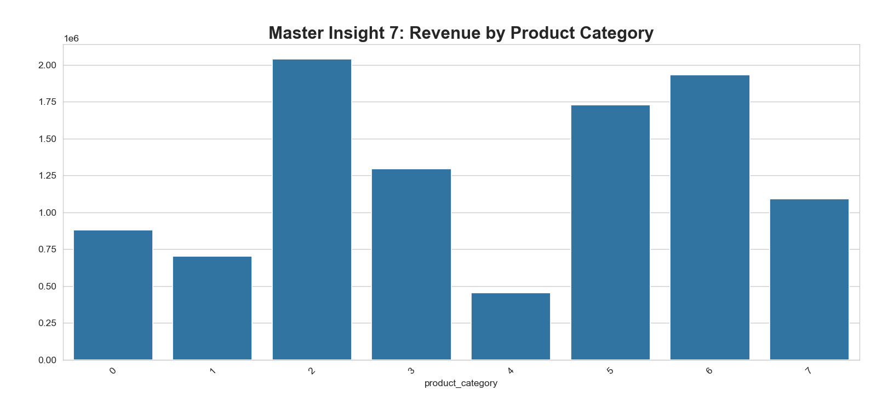

Insight 8 — High Engagement ≠ High Purchase
- Users spend time browsing but still do not purchase.
- Recommendation quality may be weak.
- Customers may face decision paralysis.
- Better CTAs and personalization are required.

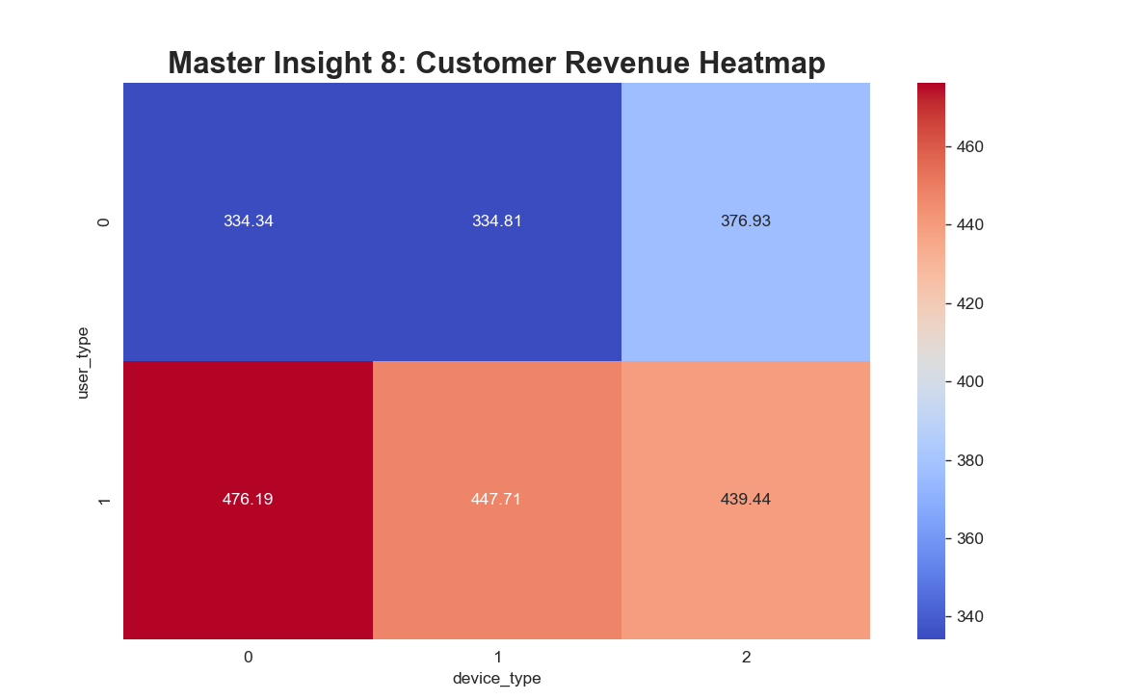

Insight 9 — Payment Method 4 Causes Abandonment
- This payment method has the highest cart drop rate.
- Payment friction directly impacts revenue loss.
- Payment gateway optimization is necessary.
- Faster and trusted payment options can help.

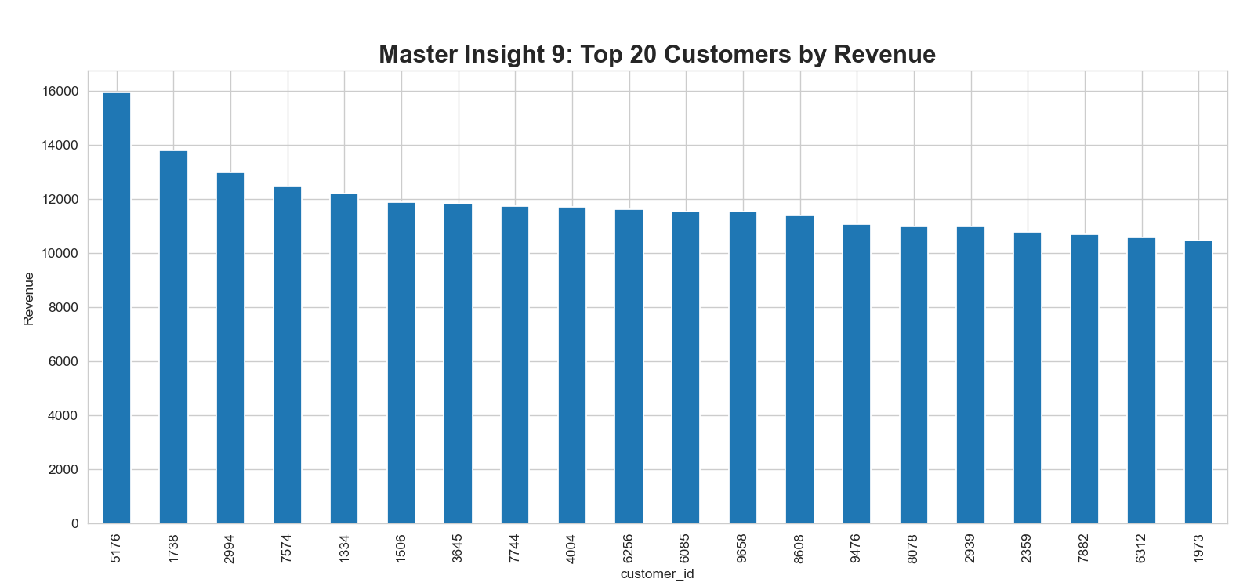

Insight 10 — VIP Customers Drive Revenue
- A small customer group contributes major revenue.
- High-value users should receive personalized offers.
- Loyalty programs can improve retention.
- VIP targeting can significantly increase lifetime value.

